The Attribute Stack
Recall that YACC maintains a parse stack to achieve shift-reduce parsing. The parse stack contains grammar symbols (both terminal and non-terminal ) representing the current configuration of the parser. Similar to the parse stack, YACC also maintains an attribute stack to store the attribute value of each grammar symbol in the parse stack.
The attribute stack is synchronous with the parse stack -- synchronous because the i'th value on the attribute stack will be the attribute value of the i'th symbol on the parse stack.
We will see how attribute synthesis is done on input 2+3*(4+5).
1. The main() function in y.tab.c begins execution. It calls yyparse() which in turn calls yylex() for tokens.
2. yylex() reads the input and finds that the lexeme "2" matches with the pattern for the token DIGIT. It assigns ‘2’ to yylval and returns DIGIT. Note that YYSTYPE is assumed to take its default value of integer and hence yylval is set to integer type by YACC.
3. yyparse() which obtains the token DIGIT and its attribute value inside the variable yylval, shifts the token DIGIT to the parser stack and pushes the value of yylval (2) to the attribute stack.
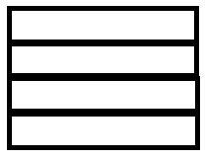
INITIAL PARSE STACK INITIAL ATTRIBUTE STACK
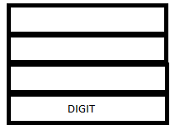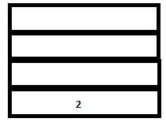
PARSE STACK-AFTER SHIFT ATTRIBUTE STACK-AFTER SHIFT
5. A reduction (corresponding to the rule expr: DIGIT) takes place. This results in the following events:
1. The terminal ‘ DIGIT’ gets replaced with the non-terminal expr in the parser stack.
2. The semantic action {$$=$1} for the corresponding reduction is executed. (This sets the (attribute) value of the non terminal at the head of the rule (‘expr’) to the (attribute) value of the first symbol in the handle (DIGIT).)
3. The value of DIGIT (2) is popped from the attribute stack and the synthesized value of ‘expr’(2) is pushed into it.
Note that at any point in the parser’s execution, the symbols $1, $2, $3 etc., refers to the first, second, third etc. attribute values (of the corresponding tokens) on top of the stack. $$ refers to the attribute value of the non-terminal which is the head of the production. When the non-terminal is pushed on to the parse stack, the value of $$ is pushed on to the attribute stack. $$ refers to the symbol on top of the stack after a reduction has taken place.
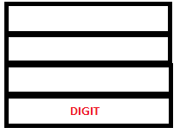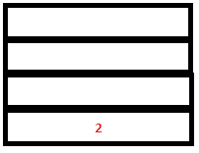
PARSE STACK-BEFORE READ ATTRIBUTE STACK-BEFORE READ
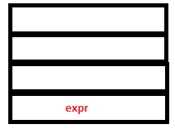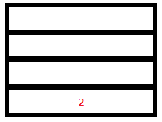
PARSE STACK-AFTER READ ATTRIBUTE STACK-AFTER READ
6. The parser executes a shift action. Now Lex reads and returns the token ‘+’. Since this is a literal token, its value, ‘+’ gets pushed into both the parse stack and the attribute stack after implicit type coercion .
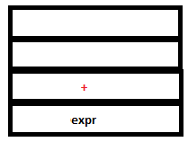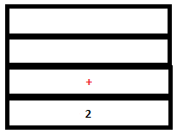
PARSE STACK-AFTER SHIFT ATTRIBUTE STACK-AFTER SHIFT
7. Since there are no possible reductions to be performed, parser executes another shift operation. Lex returns the token DIGIT again as it encounters ‘3’. The token DIGIT gets pushed to the parser stack and its value, ‘3’, gets pushed to the attribute stack.
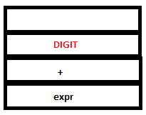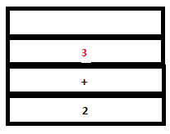
PARSE STACK-AFTER SHIFT ATTRIBUTE STACK-AFTER SHIFT
8. The reduction by the rule expr: DIGIT takes place. The token DIGIT in parse stack is replaced by ‘expr’. The semantic action {$$=$1} sets the value of ‘expr’ to ‘3. In the attribute stack, the value of DIGIT (3) gets replaced by the value of expr (3 itself).
PARSE STACK-BEFORE READ ATTRIBUTE STACK-BEFORE READ
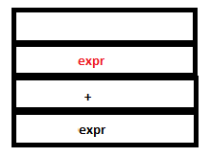
PARSE STACK-AFTER READ ATTRIBUTE STACK-AFTER READ
9. Now even though a valid reduction is possible for expr + expr, the parser executes a shift action. This is because shift/reduce conflict is resolved by looking at operator precedence. Recall shift/reduce parsing. The next token, ‘*’ is returned by Lex. This is again a literal token and is pushed into both the parse stack and attribute stack.
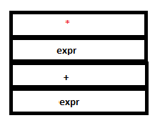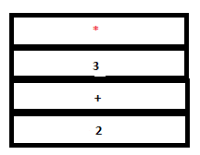
PARSE STACK-AFTER SHIFT ATTRIBUTE STACK-AFTER SHIFT
10. Since there are no matching handles in any of the rules, another shift action is executed. Lex returns ‘(‘ which is again a literal token. The configuration is now
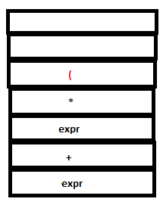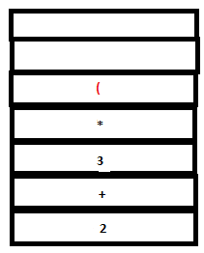
PARSE STACK-AFTER SHIFT ATTRIBUTE STACK-AFTER SHIFT
11. Again, there are no matching rules. So another shift action is executed. Lex returns DIGIT for ‘4’.
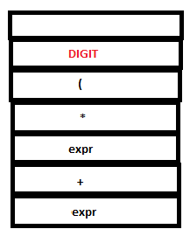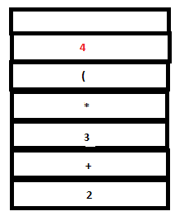
PARSE STACK-AFTER SHIFT ATTRIBUTE STACK-AFTER SHIFT
12. A reduction by expr:DIGIT takes place.
PARSE STACK-BEFORE READ ATTRIBUTE STACK-BEFORE READ
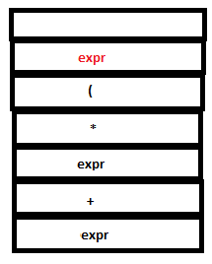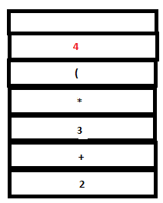
PARSE STACK-AFTER READ ATTRIBUTE STACK-AFTER READ
13. Since there are no matching rules, a shift action is executed. The literal token ‘+’ is returned by Lex and pushed into both stacks by YACC.
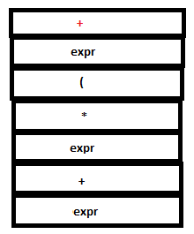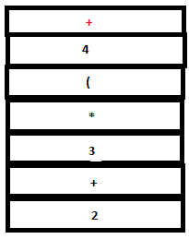
PARSE STACK-AFTER SHIFT ATTRIBUTE STACK-AFTER SHIFT
14. Since there are no matching rules, another shift action is executed. Lex returns DIGIT for ‘5’.
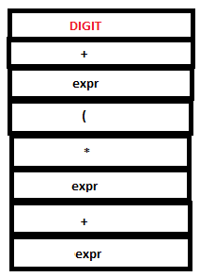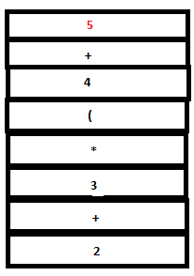
PARSE STACK-AFTER SHIFT ATTRIBUTE STACK-AFTER SHIFT
15. A reduction by the rule expr:DIGIT takes place.
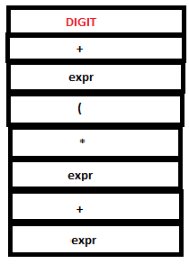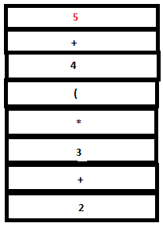
PARSE STACK-BEFORE READ ATTRIBUTE STACK-BEFORE READ
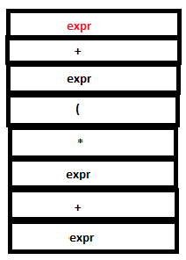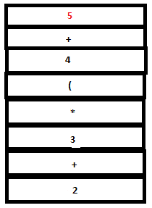
PARSE STACK-AFTER READ ATTRIBUTE STACK-AFTER READ
16. The parse stack now contains ‘expr + expr’. Now a reduction by the rule expr : expr ‘+’ expr takes place. The tokens ‘expr’, ‘+’ and ‘expr’ in the parse stack are replaced by a single ‘expr’. The semantic action {$$=$1+$3} executes. $1 and $3 refer to the first and third values in the attribute stack , that is, 4 and 5 respectively. Hence the value of the head($$), ‘expr’, is set to 4+5(=9). ‘4’ ,’+’, and ‘5’ are popped out from the stack and ‘9’ is pushed in.
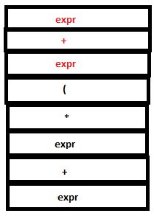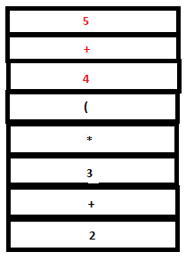
PARSE STACK-BEFORE READ ATTRIBUTE STACK-BEFORE READ
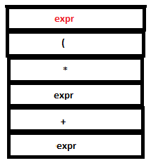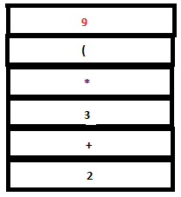
PARSE STACK-AFTER READ ATTRIBUTE STACK-AFTER READ
17. Since there are no matching reductions, a shift action takes place. Lexer returns the literal token ‘)’ which is pushed to both parser stack and attribute stack.
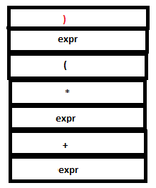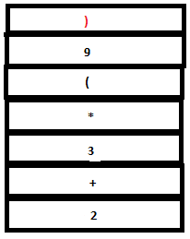
PARSE STACK-AFTER SHIFT ATTRIBUTE STACK-AFTER SHIFT
18. Now a reduction by the rule expr: ‘(‘ expr ‘)’ takes place. The tokens ‘(‘ , expr and ‘)’ in the parser stack are replace by a single expr and the symbols ‘(‘ ,’9’ and ‘)’ in the attribute stack are replaced by ‘9’. (Since the semantic action sets $$ to $2 which is ‘9’).
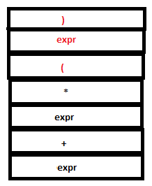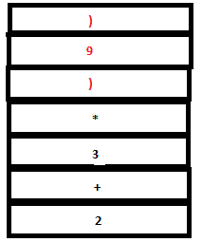
PARSE STACK-BEFORE READ ATTRIBUTE STACK-BEFORE READ
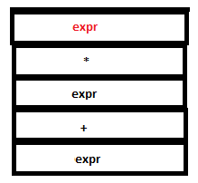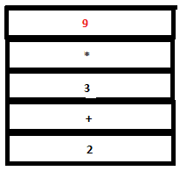
PARSE STACK-AFTER READ ATTRIBUTE STACK-AFTER READ
19. Now we have expr*expr on the top of the parser stack. Reduction by the rule expr: expr ‘*’ expr occurs. The tokens ‘expr’, ‘*’ and ‘expr’ are removed from the parse stack and a single ‘expr’ is pushed instead. The symbols ‘3’, ‘*’ and ‘9’ are replaced by ‘27’ (that is, 3*9) in the attribute stack.
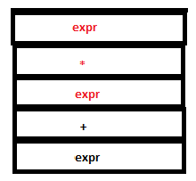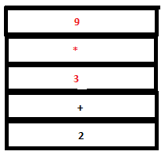
PARSE STACK-BEFORE READ ATTRIBUTE STACK-BEFORE READ
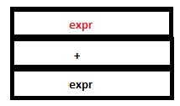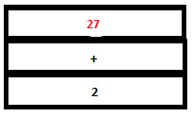
PARSE STACK-AFTER READ ATTRIBUTE STACK-AFTER READ
20. Reduction by the rule expr: expr ‘+’ expr takes place. Now we have a single ‘expr’ in the parser stack and ‘29’ in the attribute stack.
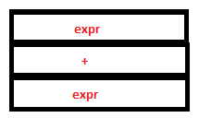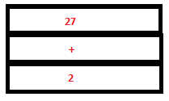
PARSE STACK-BEFORE READ ATTRIBUTE STACK-BEFORE READ

PARSE STACK-AFTER READ ATTRIBUTE STACK-AFTER READ
21. Finally, lexer returns the ‘\n’ character and the final reduction to ‘start’ occurs by the rule start: expr ‘\n’. The semantic action prints ‘29’.
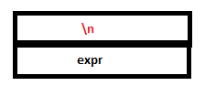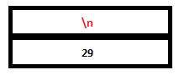
PARSE STACK-AFTER SHIFT ATTRIBUTE STACK-AFTER SHIFT
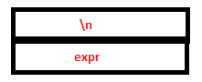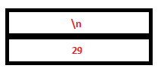
PARSE STACK-BEFORE READ ATTRIBUTE STACK-BEFORE READ
,/a  
PARSE STACK-AFTER READ ATTRIBUTE STACK-AFTER READ
22. Lexer now encounters end of input (You need to enter Ctrl+D to indicate end of input as input is being read from stdout.) As a result yylex calls yywrap() which returns a non-zero value indication end of input. yylex() returns 0. (The $ in the input buffer stands for the end of input marker.)
23. When yyparse receives 0 from lexer, it returns 0 to main function to indicate that parsing was successfull.
The following table shows the configuration of the parse stack and the attribute stack at every step of the parsing process. Assume that whenever yylex() returns a token with no attribute, yyparse() pushes a '.' to the attribute stack.
PARSE STACK | ATTRIBUTE STACK | I/P BUFFER | PARSER-ACTION EXECUTED
 |  | 2 + 3 * (4 + 5) $ | _
DIGIT | 2 | + 3 * ( 4 + 5 ) $ | SHIFT
expr | 2 | + 3 * ( 4 + 5 ) $ | REDUCE
expr + | 2 . | 3 * ( 4 + 5 ) $ | SHIFT
expr + DIGIT | 2 . 3 | * ( 4 + 5 ) $ | SHIFT
expr + expr | 2 . 3 | * ( 4 + 5) $ | REDUCE
expr + expr * | 2 . 3 . | ( 4 + 5 ) $ | SHIFT
expr + expr * ( | 2 . 3 . . | 4 + 5 ) $ | SHIFT
expr + expr * ( DIGIT | 2 . 3 . . 4 | + 5 ) $ | SHIFT
expr + expr * ( expr | 2 . 3 . . 4 | + 5 ) $ | REDUCE
expr + expr * ( expr + | 2 . 3 . . 4 . | 5 ) $ | SHIFT
expr + expr * ( expr + DIGIT | 2 . 3 . . 4 . 5 | ) $ | SHIFT
expr + expr * ( expr + expr | 2 . 3 . . 4 . 5 | ) $ | REDUCE
expr + expr * ( expr | 2 . 3 . . 9 | ) $ | REDUCE
expr + expr * ( expr ) | 2 . 3 . . 9 . | $ | SHIFT
expr + expr * expr | 2 . 3 . 9 | $ | REDUCE
expr + expr | 2 . 27 | $ | REDUCE
expr | 29 | $ | REDUCE
$expr | 29 | $ | ACCEPT

